类小红书

[元数据建模信息有限公司]

|  |
| --- |
| 类小红书 |

文档信息

|  |  |  |  |
| --- | --- | --- | --- |
| 项目名称： | 类小红书 | | |
| 项目经理： | 杨松<yangsong158@qq.com> | 模型编号： | 4.5.0 |
| 模型创建日期： | 2023-3-20 09:21:33 | 模型更新日期： | 2023-3-20 17:30:35 |
| 起草人： | 元数建模自动生成 | 文档创建日期： |  |
| 复审人： | 杨松<yangsong158@qq.com> | 复审日期： |  |
| 项目说明： | 类小红书 | | |
| 官方网站： | <http://www.chiner.com.cn/> | | |
| 开源代码： | <https://gitee.com/robergroup/chiner.git>  <https://gitee.com/robergroup/chiner-java.git> | | |
| 联系作者： |  | | |

# users-用户

## 关系图

### user_auths_login-[用户联合登录]

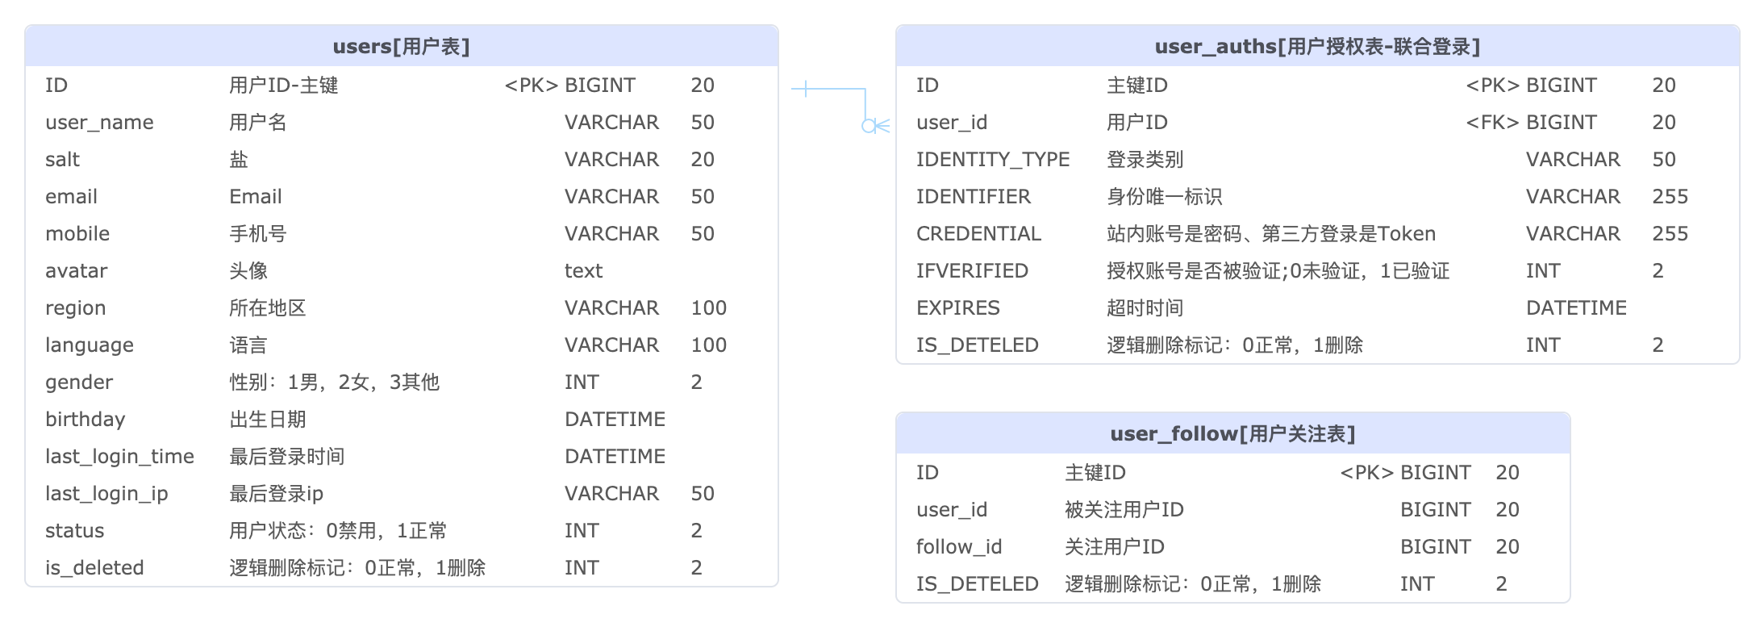

## 表清单

|  |  |  |  |
| --- | --- | --- | --- |
| **#** | **数据表** | **名称** | **备注说明** |
| 1 | users | 用户表 |  |
| 2 | user_auths | 用户授权表-联合登录 |  |
| 3 | user_follow | 用户关注表 |  |

## 表字段明细

### users [用户表]

|  |  |  |  |  |  |  |  |
| --- | --- | --- | --- | --- | --- | --- | --- |
| **#** | **字段** | **名称** | **数据类型** | **主键** | **非空** | **默认值** | **备注说明** |
| 1 | ID | 用户ID-主键 | BIGINT(20) | √ | √ |  |  |
| 2 | user_name | 用户名 | VARCHAR(50) |  | √ |  |  |
| 3 | salt | 盐 | VARCHAR(20) |  | √ |  |  |
| 4 | email | Email | VARCHAR(50) |  |  |  |  |
| 5 | mobile | 手机号 | VARCHAR(50) |  |  |  |  |
| 6 | avatar | 头像 | text |  |  |  |  |
| 7 | region | 所在地区 | VARCHAR(100) |  |  |  |  |
| 8 | language | 语言 | VARCHAR(100) |  |  | 'English' |  |
| 9 | gender | 性别：1男，2女，3其他 | INT(2) |  |  |  | <字典:gender> |
| 10 | birthday | 出生日期 | DATETIME |  |  |  |  |
| 11 | last_login_time | 最后登录时间 | DATETIME |  |  |  |  |
| 12 | last_login_ip | 最后登录ip | VARCHAR(50) |  |  |  |  |
| 13 | status | 用户状态：0禁用，1正常 | INT(2) |  | √ | 1 | <字典:user_status> |
| 14 | is_deleted | 逻辑删除标记：0正常，1删除 | INT(2) |  | √ | 0 | <字典:is_deleted> |
| 15 | CREATED_BY | 创建人 | BIGINT(20) |  |  |  |  |
| 16 | CREATED_TIME | 创建时间 | DATETIME |  |  |  |  |
| 17 | UPDATED_BY | 更新人 | BIGINT(20) |  |  |  |  |
| 18 | UPDATED_TIME | 更新时间 | DATETIME |  |  |  |  |

### user_auths [用户授权表-联合登录]

|  |  |  |  |  |  |  |  |
| --- | --- | --- | --- | --- | --- | --- | --- |
| **#** | **字段** | **名称** | **数据类型** | **主键** | **非空** | **默认值** | **备注说明** |
| 1 | ID | 主键ID | BIGINT(20) | √ | √ |  |  |
| 2 | user_id | 用户ID | BIGINT(20) |  | √ |  |  |
| 3 | IDENTITY_TYPE | 登录类别 | VARCHAR(50) |  | √ | 'PWD' | <字典:identity_type> |
| 4 | IDENTIFIER | 身份唯一标识 | VARCHAR(255) |  |  |  | USER_ID,FB id,google id,Ins id |
| 5 | CREDENTIAL | 站内账号是密码、第三方登录是Token | VARCHAR(255) |  |  |  |  |
| 6 | IFVERIFIED | 授权账号是否被验证;0未验证，1已验证 | INT(2) |  |  | 0 | <字典:ifverified> |
| 7 | EXPIRES | 超时时间 | DATETIME |  |  |  |  |
| 8 | IS_DETELED | 逻辑删除标记：0正常，1删除 | INT(2) |  |  | 0 | <字典:is_deleted> |
| 9 | CREATED_BY | 创建人 | BIGINT(20) |  |  |  |  |
| 10 | CREATED_TIME | 创建时间 | DATETIME |  |  |  |  |
| 11 | UPDATED_BY | 更新人 | BIGINT(20) |  |  |  |  |
| 12 | UPDATED_TIME | 更新时间 | DATETIME |  |  |  |  |

### user_follow [用户关注表]

|  |  |  |  |  |  |  |  |
| --- | --- | --- | --- | --- | --- | --- | --- |
| **#** | **字段** | **名称** | **数据类型** | **主键** | **非空** | **默认值** | **备注说明** |
| 1 | ID | 主键ID | BIGINT(20) | √ | √ |  |  |
| 2 | user_id | 被关注用户ID | BIGINT(20) |  | √ |  |  |
| 3 | follow_id | 关注用户ID | BIGINT(20) |  | √ |  |  |
| 4 | IS_DETELED | 逻辑删除标记：0正常，1删除 | INT(2) |  |  | 0 | <字典:is_deleted> |
| 5 | CREATED_BY | 创建人 | BIGINT(20) |  |  |  |  |
| 6 | CREATED_TIME | 创建时间 | DATETIME |  |  |  |  |
| 7 | UPDATED_BY | 更新人 | BIGINT(20) |  |  |  |  |
| 8 | UPDATED_TIME | 更新时间 | DATETIME |  |  |  |  |

## 数据字典明细

### gender [性别]

|  |  |  |  |
| --- | --- | --- | --- |
| **#** | **代码** | **名称** | **备注说明** |
| 1 | 1 | 男 |  |
| 2 | 2 | 女 |  |
| 3 | 3 | 其他 |  |

### user_status [用户状态]

|  |  |  |  |
| --- | --- | --- | --- |
| **#** | **代码** | **名称** | **备注说明** |
| 1 | 0 | 禁用 |  |
| 2 | 1 | 正常 |  |

### is_deleted [逻辑删除标记]

|  |  |  |  |
| --- | --- | --- | --- |
| **#** | **代码** | **名称** | **备注说明** |
| 1 | 0 | 正常 |  |
| 2 | 1 | 删除 |  |

### identity_type [登录类型]

|  |  |  |  |
| --- | --- | --- | --- |
| **#** | **代码** | **名称** | **备注说明** |
| 1 | PWD | 用户名密码登录 |  |
| 2 | GOOGLE | GOOGLE登录 |  |
| 3 | FB | FACEBOOK登录 |  |
| 4 | INS | INSTAGRAM登录 |  |

### ifverified [授权账号是否已验证]

|  |  |  |  |
| --- | --- | --- | --- |
| **#** | **代码** | **名称** | **备注说明** |
| 1 | 0 | 未验证 |  |
| 2 | 1 | 已严重 |  |

# posts-博文

## 关系图

### post-relation-[文章关系图]

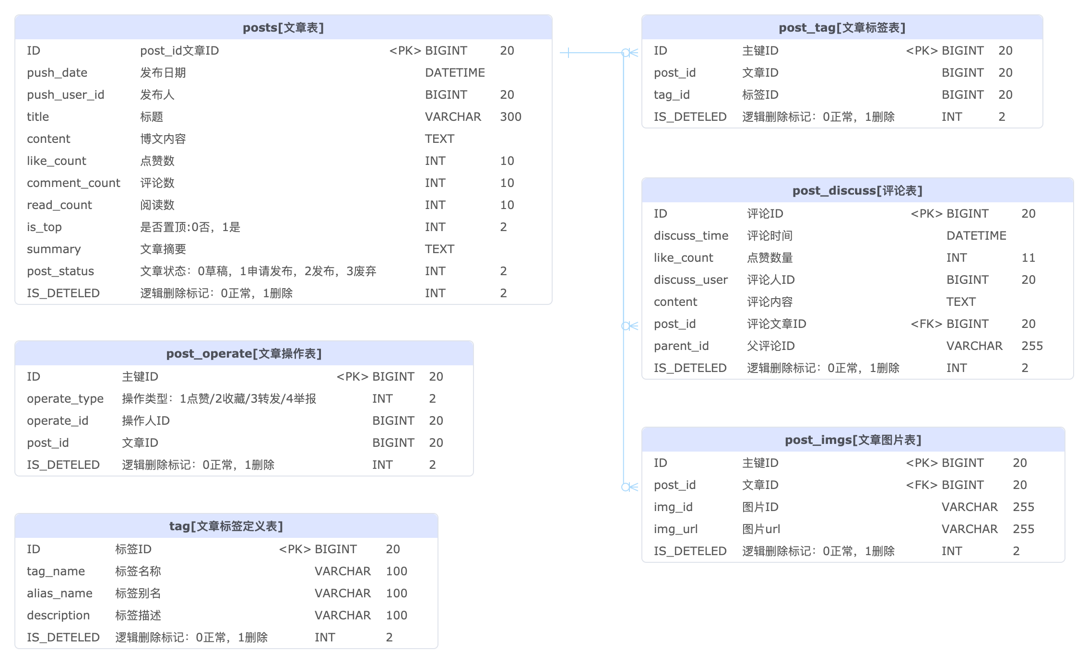

## 表清单

|  |  |  |  |
| --- | --- | --- | --- |
| **#** | **数据表** | **名称** | **备注说明** |
| 1 | posts | 文章表 |  |
| 2 | post_tag | 文章标签表 |  |
| 3 | post_discuss | 评论表 |  |
| 4 | post_operate | 文章操作表 |  |
| 5 | post_imgs | 文章图片表 |  |
| 6 | tag | 文章标签定义表 |  |

## 表字段明细

### posts [文章表]

|  |  |  |  |  |  |  |  |
| --- | --- | --- | --- | --- | --- | --- | --- |
| **#** | **字段** | **名称** | **数据类型** | **主键** | **非空** | **默认值** | **备注说明** |
| 1 | ID | post_id文章ID | BIGINT(20) | √ | √ |  |  |
| 2 | push_date | 发布日期 | DATETIME |  | √ |  |  |
| 3 | push_user_id | 发布人 | BIGINT(20) |  | √ |  |  |
| 4 | title | 标题 | VARCHAR(300) |  | √ |  |  |
| 5 | content | 博文内容 | TEXT |  | √ |  |  |
| 6 | like_count | 点赞数 | INT(10) |  |  |  |  |
| 7 | comment_count | 评论数 | INT(10) |  |  |  |  |
| 8 | read_count | 阅读数 | INT(10) |  |  |  |  |
| 9 | is_top | 是否置顶:0否，1是 | INT(2) |  |  | 0 | <字典:is_top> |
| 10 | summary | 文章摘要 | TEXT |  |  |  |  |
| 11 | post_status | 文章状态：0草稿，1申请发布，2发布，3废弃 | INT(2) |  |  | 0 | <字典:post_status> |
| 12 | IS_DETELED | 逻辑删除标记：0正常，1删除 | INT(2) |  |  | 0 | <字典:is_deleted> |
| 13 | CREATED_BY | 创建人 | BIGINT(20) |  |  |  |  |
| 14 | CREATED_TIME | 创建时间 | DATETIME |  |  |  |  |
| 15 | UPDATED_BY | 更新人 | BIGINT(20) |  |  |  |  |
| 16 | UPDATED_TIME | 更新时间 | DATETIME |  |  |  |  |

### post_tag [文章标签表]

|  |  |  |  |  |  |  |  |
| --- | --- | --- | --- | --- | --- | --- | --- |
| **#** | **字段** | **名称** | **数据类型** | **主键** | **非空** | **默认值** | **备注说明** |
| 1 | ID | 主键ID | BIGINT(20) | √ | √ |  |  |
| 2 | post_id | 文章ID | BIGINT(20) |  |  |  |  |
| 3 | tag_id | 标签ID | BIGINT(20) |  |  |  |  |
| 4 | IS_DETELED | 逻辑删除标记：0正常，1删除 | INT(2) |  |  | 0 | <字典:is_deleted> |
| 5 | CREATED_BY | 创建人 | BIGINT(20) |  |  |  |  |
| 6 | CREATED_TIME | 创建时间 | DATETIME |  |  |  |  |
| 7 | UPDATED_BY | 更新人 | BIGINT(20) |  |  |  |  |
| 8 | UPDATED_TIME | 更新时间 | DATETIME |  |  |  |  |

### post_discuss [评论表]

|  |  |  |  |  |  |  |  |
| --- | --- | --- | --- | --- | --- | --- | --- |
| **#** | **字段** | **名称** | **数据类型** | **主键** | **非空** | **默认值** | **备注说明** |
| 1 | ID | 评论ID | BIGINT(20) | √ | √ |  |  |
| 2 | discuss_time | 评论时间 | DATETIME |  |  |  |  |
| 3 | like_count | 点赞数量 | INT(11) |  |  |  |  |
| 4 | discuss_user | 评论人ID | BIGINT(20) |  |  |  |  |
| 5 | content | 评论内容 | TEXT |  |  |  |  |
| 6 | post_id | 评论文章ID | BIGINT(20) |  |  |  |  |
| 7 | parent_id | 父评论ID | VARCHAR(255) |  |  |  |  |
| 8 | IS_DETELED | 逻辑删除标记：0正常，1删除 | INT(2) |  |  | 0 | <字典:is_deleted> |
| 9 | CREATED_BY | 创建人 | BIGINT(20) |  |  |  |  |
| 10 | CREATED_TIME | 创建时间 | DATETIME |  |  |  |  |
| 11 | UPDATED_BY | 更新人 | BIGINT(20) |  |  |  |  |
| 12 | UPDATED_TIME | 更新时间 | DATETIME |  |  |  |  |

### post_operate [文章操作表]

|  |  |  |  |  |  |  |  |
| --- | --- | --- | --- | --- | --- | --- | --- |
| **#** | **字段** | **名称** | **数据类型** | **主键** | **非空** | **默认值** | **备注说明** |
| 1 | ID | 主键ID | BIGINT(20) | √ | √ |  |  |
| 2 | operate_type | 操作类型：1点赞/2收藏/3转发/4举报 | INT(2) |  |  |  | <字典:operate_type> |
| 3 | operate_id | 操作人ID | BIGINT(20) |  |  |  |  |
| 4 | post_id | 文章ID | BIGINT(20) |  |  |  |  |
| 5 | IS_DETELED | 逻辑删除标记：0正常，1删除 | INT(2) |  |  | 0 | <字典:is_deleted> |
| 6 | CREATED_BY | 创建人 | BIGINT(20) |  |  |  |  |
| 7 | CREATED_TIME | 创建时间 | DATETIME |  |  |  |  |
| 8 | UPDATED_BY | 更新人 | BIGINT(20) |  |  |  |  |
| 9 | UPDATED_TIME | 更新时间 | DATETIME |  |  |  |  |

### post_imgs [文章图片表]

|  |  |  |  |  |  |  |  |
| --- | --- | --- | --- | --- | --- | --- | --- |
| **#** | **字段** | **名称** | **数据类型** | **主键** | **非空** | **默认值** | **备注说明** |
| 1 | ID | 主键ID | BIGINT(20) | √ | √ |  |  |
| 2 | post_id | 文章ID | BIGINT(20) |  | √ |  |  |
| 3 | img_id | 图片ID | VARCHAR(255) |  |  |  |  |
| 4 | img_url | 图片url | VARCHAR(255) |  |  |  |  |
| 5 | IS_DETELED | 逻辑删除标记：0正常，1删除 | INT(2) |  |  | 0 | <字典:is_deleted> |
| 6 | CREATED_BY | 创建人 | BIGINT(20) |  |  |  |  |
| 7 | CREATED_TIME | 创建时间 | DATETIME |  |  |  |  |
| 8 | UPDATED_BY | 更新人 | BIGINT(20) |  |  |  |  |
| 9 | UPDATED_TIME | 更新时间 | DATETIME |  |  |  |  |

### tag [文章标签定义表]

|  |  |  |  |  |  |  |  |
| --- | --- | --- | --- | --- | --- | --- | --- |
| **#** | **字段** | **名称** | **数据类型** | **主键** | **非空** | **默认值** | **备注说明** |
| 1 | ID | 标签ID | BIGINT(20) | √ | √ |  |  |
| 2 | tag_name | 标签名称 | VARCHAR(100) |  |  |  |  |
| 3 | alias_name | 标签别名 | VARCHAR(100) |  |  |  |  |
| 4 | description | 标签描述 | VARCHAR(100) |  |  |  |  |
| 5 | IS_DETELED | 逻辑删除标记：0正常，1删除 | INT(2) |  |  | 0 | <字典:is_deleted> |
| 6 | CREATED_BY | 创建人 | BIGINT(20) |  |  |  |  |
| 7 | CREATED_TIME | 创建时间 | DATETIME |  |  |  |  |
| 8 | UPDATED_BY | 更新人 | BIGINT(20) |  |  |  |  |
| 9 | UPDATED_TIME | 更新时间 | DATETIME |  |  |  |  |

## 数据字典明细

### operate_type [操作类型]

|  |  |  |  |
| --- | --- | --- | --- |
| **#** | **代码** | **名称** | **备注说明** |
| 1 | 1 | 点赞 |  |
| 2 | 2 | 收藏 |  |
| 3 | 3 | 转发 |  |
| 4 | 4 | 举报 |  |

### is_top [是否置顶]

|  |  |  |  |
| --- | --- | --- | --- |
| **#** | **代码** | **名称** | **备注说明** |
| 1 | 0 | 否 |  |
| 2 | 1 | 是 |  |

### post_status [文章状态]

|  |  |  |  |
| --- | --- | --- | --- |
| **#** | **代码** | **名称** | **备注说明** |
| 1 | 0 | 草稿 |  |
| 2 | 1 | 申请发布 |  |
| 3 | 2 | 发布 |  |
| 4 | 3 | 废弃 |  |

# msgs-消息管理

## 关系图

## 表清单

|  |  |  |  |
| --- | --- | --- | --- |
| **#** | **数据表** | **名称** | **备注说明** |
| 1 | messages | 消息管理表 |  |

## 表字段明细

### messages [消息管理表]

|  |  |  |  |  |  |  |  |
| --- | --- | --- | --- | --- | --- | --- | --- |
| **#** | **字段** | **名称** | **数据类型** | **主键** | **非空** | **默认值** | **备注说明** |
| 1 | ID | 主键ID | BIGINT(20) | √ | √ |  |  |
| 2 | user_id | 接收用户ID | BIGINT(20) |  | √ |  |  |
| 3 | msg_type | 消息类型 | INT(2) |  | √ |  | <字典:msg_type> |
| 4 | msg_content | 消息内容 | VARCHAR(255) |  | √ |  |  |
| 5 | is_sended | 是否已发送，0未发送，1已发送，2发送错误 | INT(2) |  |  | 0 | <字典:is_sended> |
| 6 | error_msg | 发送错误信息 | VARCHAR(255) |  |  |  |  |
| 7 | send_flag | 发送标记，1立即发送，2延迟发送 | INT(2) |  |  | 1 | <字典:send_flag> |
| 8 | delay_time | 延迟发送时间 | DATETIME |  |  |  |  |
| 9 | IS_DETELED | 逻辑删除标记：0正常，1删除 | INT(2) |  |  | 0 | <字典:is_deleted> |
| 10 | CREATED_BY | 创建人 | BIGINT(20) |  |  |  |  |
| 11 | CREATED_TIME | 创建时间 | DATETIME |  |  |  |  |
| 12 | UPDATED_BY | 更新人 | BIGINT(20) |  |  |  |  |
| 13 | UPDATED_TIME | 更新时间 | DATETIME |  |  |  |  |

## 数据字典明细

### is_sended [是否已发送]

|  |  |  |  |
| --- | --- | --- | --- |
| **#** | **代码** | **名称** | **备注说明** |
| 1 | 0 | 未发送 |  |
| 2 | 1 | 已发送 |  |

### send_flag [发送标记]

|  |  |  |  |
| --- | --- | --- | --- |
| **#** | **代码** | **名称** | **备注说明** |
| 1 | 1 | 立即发送 |  |
| 2 | 2 | 延迟发送 |  |

### msg_type [消息类型]

|  |  |  |  |
| --- | --- | --- | --- |
| **#** | **代码** | **名称** | **备注说明** |
| 1 | 1 | 获赞通知 |  |
| 2 | 2 | 收藏通知 |  |
| 3 | 3 | 新增粉丝通知 |  |
| 4 | 4 | 用户评论通知 |  |
| 5 | 5 | 私信 |  |
| 6 | 6 | 系统通知 |  |